GRAPH ANALYSIS

(PAKISTANI DISHES)

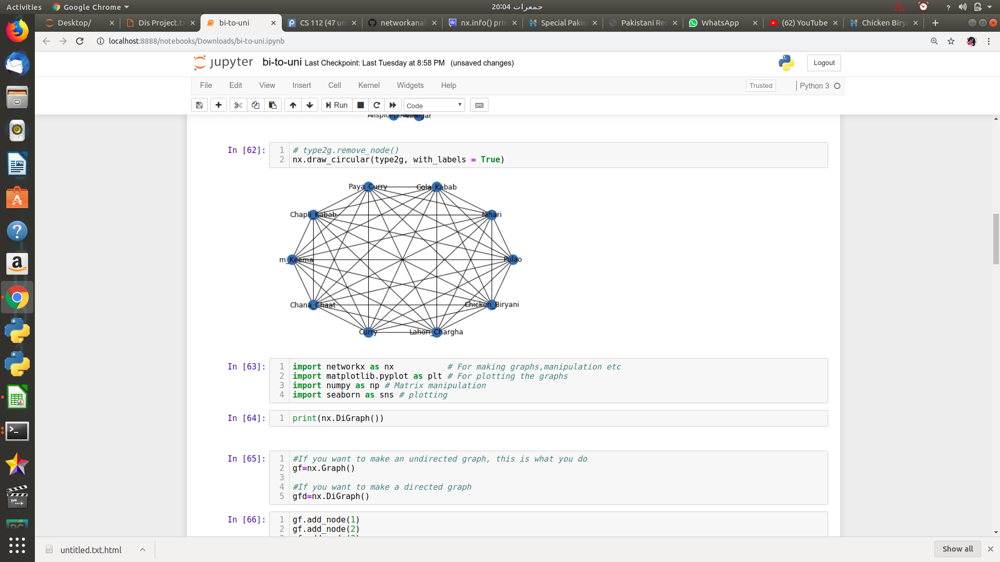INTRODUCTION:

Figure 1: unipartite

Graph analysis is of pakistani recipes that have nodes ,edge and vertex through that we gonna make/analyse our graphs in a different ways that are described below with related pictures

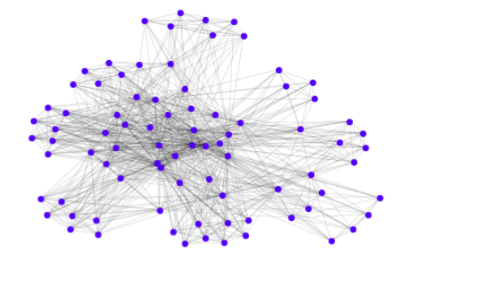

Figure 2: unipartite

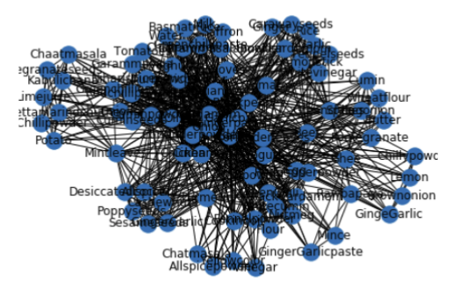

BRIEF DESCRIPTION:

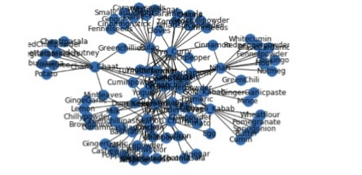Our project is on the Pakistani recipes/dishes .we can analysis on the basis of our project that which ingredient is mostly used in Pakistani recipes. There are total 12 recipes that we have taken as our data. Reference *www.hamariweb.com/recipes/special_pakistani_dishes_scid11.aspx*.

Figure 3: unipartite

Network represent the number of nodes: 84,

Number of edges: 957, average degree: 22.7857

our text file have 2 nodes that why bipartite graph was formed then we convert it into unipartite beacuse unipartite are more useful

every dish have every relation so this is complete graph this is clustering

Figure 4: bipartite

average degree:22.7857